Project 3: MP3 player

Team member: Jialang Huang (jialangh@buffalo.edu)

Haoquan Zhao([haoquanz@buffalo.edu](mailto:haoquanz@buffalo.edu))

Division of work:

1. Base mp3 player with 5 button to control mp3 player, and a LCD display to display song’s information and the volume by Jialang Huang
2. LED light flash base on the beats of the music by Haoquan Zhao

Project material:

* An Adafruit Metro M0 express
* SODIAL DFPlayer mini MP3 player module
* A LCD display: LCD1602 display module and IIC protocol
* 5 switch buttons
* A 3.5mm jack breakout board
* A 2 GB SD card
* 5 LED
* MSGEQ7 Graphic Equalizer Display Filter

Project goals:

A MP3 music player. It has a LCD display for display song’s artist and title, 5 buttons to set pause, next, previous, volume up and volume down. LED light flash based on the beats of the music.

Implementation timeline:

November 4th to November 10th: prepare project materials

November 11th to November 16th: write code and test the MP3 player and LCD display.

November 17th to November 24th: write code and test the LED flash.

Challenges and overcome:

* DFPlayer have a library (DFRobotDFPlayerMini.h) for Arduino, but Adafruit Metro M0 express cannot use this library. Base on DFPlayerMini datasheet, we use Arduino Serial function to send a CMD to DFPlayer, so that we can control the MP3 player by pressing the button.
* For the functionality of the led flash to the music. If we want to implement this functionality we will have to find a way to quantify the music. We use the chip MSGEQ7 as a tool to quantify the music. The audio have different audio sequences, we set the certain led react to the different audio sequence.

Block diagram with functional description:

We use the MSGEQ7 to implement the function of the led flash to the music. The MSGEQ7 chip read the audio input and then detect 7 sequence ranges of the music and then split it into 7 bands. The led will react the base on the band that it receives. The seven frequencies are peak detected and multiplexed to the output to provide a DC representation of the amplitude of each band 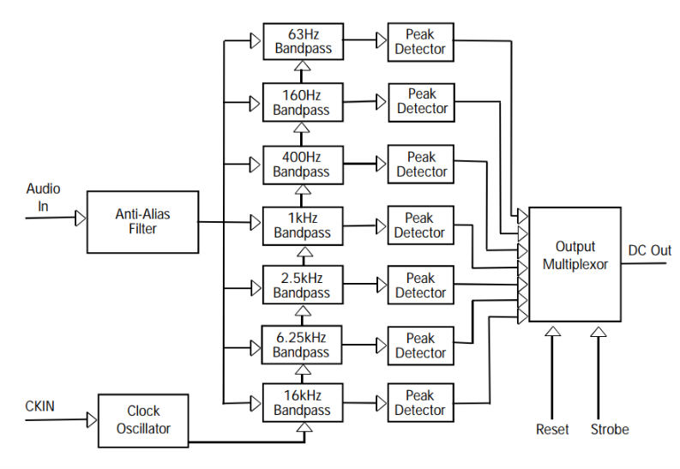

Detailed description of one "interesting" functional component